**The First Reformed Church of Nyack**

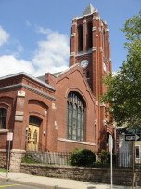

linkedin.com/groups/FirstReformedChurchNyack



[facebook.com/groups/frcnyack](http://www.facebook.com/groups/frcnyack)



[nyackreformed.org](http://www.nyackreformed.org)

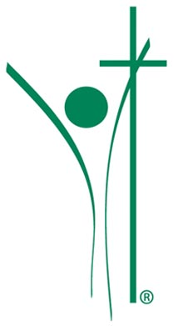

Church Location: 18 South Broadway, Nyack, NY 10960

Mailing Address: Box 565, Nyack, NY 10960

Office: 845.358.5518

Church Email: [frchurch@optonline.net](mailto:frchurch@optonline.net)

Website: [www.nyackreformed.org](http://www.nyackreformed.org)

Dr. Fernando Arzola Jr. Pastor/Preaching Elder

Pastor’s Email: [fred@nyackreformed.org](mailto:fred@nyackreformed.org) Home Office: 845.480.5680

Sarah Kotecha: Office Manager

James Rensink: Music Director

Gianna Alessi Song Leader

Bonnie Williams : Children’s Sunday School Coordinator

ConsistoryElders: Chuck Travers (VP), Jon Biavati (Clerk), Bruce Biavati, Alan Cann

Deacons: Kevin Graham, Katherine Rife, Skip Russell, Paul Wanamaker

*Affiliated with*

*The Reformed Church in America*

*The Regional Synod of New York*

*The Rockland-Westchester Classis*

**The First Reformed Church of Nyack**

Nyack’s Hometown Church

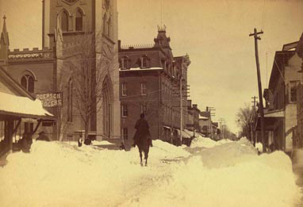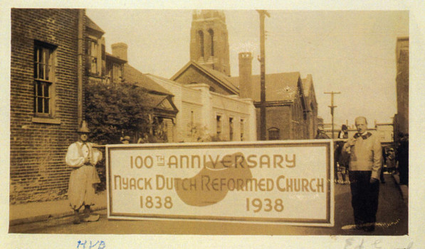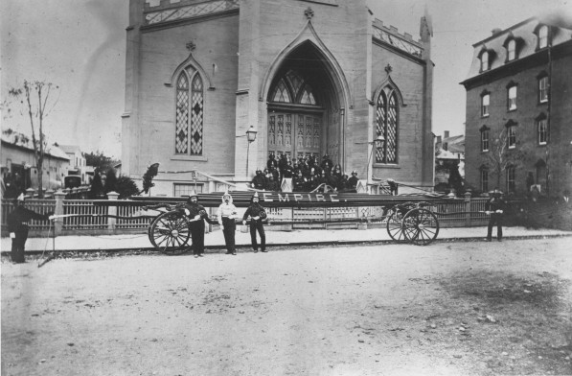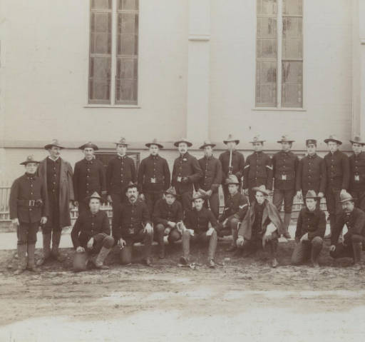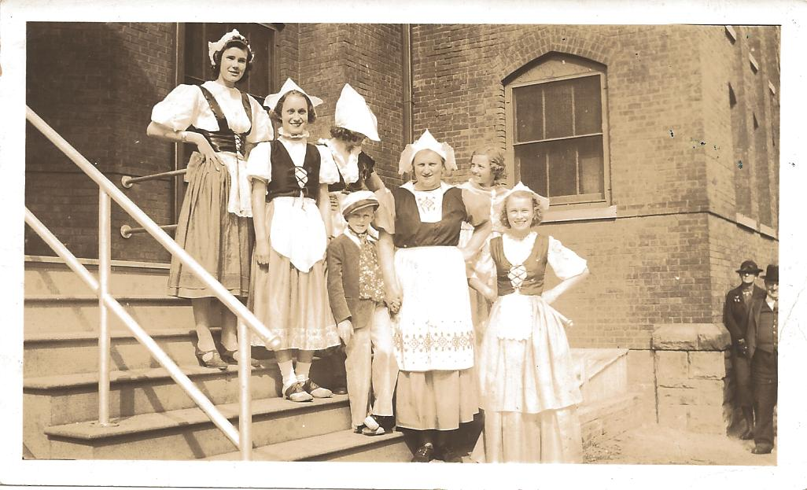

**175th ANNIVERSARY CELEBRATION**

October 20, 2013

4:00 p.m.

WELCOME .…………………………………………………………...Elder Chuck Travers

MUSIC ………………...…….….Instrumental solo by guest performer Keisuke Ikuma

Principal English Horn of The New York Philharmonic

**HYMN 516 “Bless the Lord, O My Soul”**……..………………………….....*Please stand.*

Bless the Lord, Oh my soul And all that is within me  
Bless His holy name (2X)  
  
He has done great things He has done great things  
He has done great things Bless His holy name (2X)

Bless the Lord, Oh my soul And all that is within me  
Bless His holy name (2X)

INVOCATION ………………………………………………………….Deacon Craig Russell

WORDS

Rev. Dr. Robert D. Williams President, Rockland-Westchester Classis

Rev. Thomas C. Danney Pastor, First Reformed Church, 1989-2011

Rev. Dr. William Doster Pastor, First Reformed Church, 2011-2013

Honorable Jennifer White Mayor, Village of Nyack

MUSIC …………………...….….Instrumental solo by guest performer Keisuke Ikuma

WORDS

Rev. John VandenOever Supervisor, Pastor, Piermont Reformed Church

Jefferson Weishaar Longest serving member of The Greater Consistory, Read by Deacon Craig Russell

Betty Cameron First woman on consistory

Elder Bruce Biavati Highlights from the past

Deacon Paul & Terri Wanamaker Highlights of the present

MUSIC .……………………….….Instrumental solo by guest performer Barbara Allen

Principal Harpist of The American Ballet Theatre

OFFERTORY Today’s offering will support our Youth Ministry

Deacon Kevin Graham & Elder Jon Biavati

OFFERTORY PRAYER …………………………………………………...Elder Alan Cann

SHARING THE PEACE OF CHRIST …….…………………….........................*Please stand.*

SCRIPTURE **Psalm 100** ………………………...…………………………..Margie Jennings

Chair, Pastoral Search Committee

MUSIC ……………………..….….Instrumental solo by guest performer Wendy Stern

Member of *Flute Force Quartet*, Winner of Artists International Competition

REMARKS….………………………………………………………...Dr. Fernando Arzola Jr.

Pastor/Preaching Elder

SOLO “Day by Day” …………………………………...………………Gianna Alessi

**HYMN 946 “Go My Children, with My Blessing”**……………………….....*Please stand.*

Go, my children, with my blessing, never alone.

Waking, sleeping, I am with you; you are my own.

In my love’s baptismal river I have made you mine forever.

Go, my children, with my blessing—you are my own.

Go, my children, sins forgiven, at peace and pure.

Here you learned how much I love you, what I can cure.

Here you heard my dear Son’s story; here you touched him, saw his glory.

Go, my children, sins forgiven, at peace and pure.

Go, my children, fed and nourished, closer to me;

Grow in love and love by serving, joyful and free.

Here my Spirit’s power filled you; here his tender comfort stilled you.

Go, my children, fed and nourished, joyful and free.

MUSIC ……….Strings duet performed by members Arlene Keiser and Katherine Rife

WORDS

Katherine Ogden Longest confessing member still attending

Baptized June 26, 1921

BENEDICTION ………………………………………………….Deacon Katherine Rife